#YAWEEK 2015
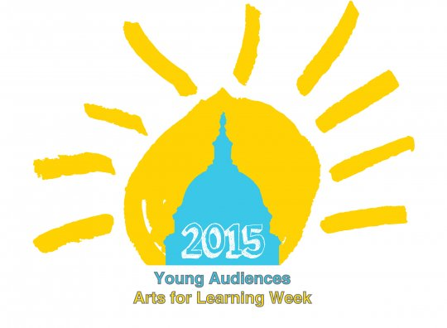
Social Media Timeline

Week 2/15-2/21
Introduce #YAWeek
2/16 – You’re invited! Celebrate with us during Young Audiences Week, March 15-21! Why are the arts important to you? #YAWeek (Link to info about YA Week – Include YA Week Graphic)
2/18 – Excited about @YoungAudiences_ #YAWeek March 15-21? So are we! Join us in showing your support for Arts-in-Education! (Link to info about YA Week)
2/20 – Show your local legislators that the #artsmatter! Reach out and share how the arts have impacted your life. #YAWeek (Link to list of local legislators)

Facebook Post:
Celebrate YA Week, March 15-21! YA Week is a time to celebrate all things YA and show
support for Arts-in-Education! For more than 60 years, Young Audiences Arts for Learning
(YA) has inspired young people and sought to expand their learning through the arts. Last year, the YA network of 30 affiliates reached 5 million children in over 6,000 schools and community centers with 85,000 performance demonstrations, workshops, and teacher services. Join us at one of our celebration events!

Week 2/22-2/28
Why are the arts important?
2/23 – Why are they Arts important? They make content more accessible, encourage active learning and enhance creativity! #YAWeek (Link to YA Video)
2/25 – 72% of business leaders rate creativity as the most important trait and cite the arts as being key to cultivating it. #YAWeek http://issuu.com/americans4arts/docs/afta_navigator_facts-and-figures
2/27 – Students with high arts participation and low socioeconomic status have a dropout rate 5x lower than their peers with low arts part. #YAWeek
Facebook Post:
Did you know that students who participate in the arts are 5x less likely to drop out of school than their peers that don’t have the same access? The arts inspire us to push the boundaries of creativity, to shake off negativity, and to strive for excellence. Young Audiences’ goal is to bring meaningful arts experiences to children across the country. Lend us your voice this YA Week, March 15-21 to help support our mission to inspire young people and expand their learning through the arts!

Week 2/29-3/7
How can you get involved in advocating for the arts?
3/2 – #YAWeek is 2 weeks away! Here are some advocacy tools to show your support for Arts-in-Education for all! (Link to page with advocacy tips for individuals – with legislator info, and tips for how to write an effective advocacy letter) http://www.americansforthearts.org/by-program/reports-and-data/legislation-policy/legislative-issue-center/advocacy-toolkit-for-individuals
3/4 – Want to get involved? Here are some easy ways that you can advocate for #artsed in your schools! http://www.arteducators.org/advocacy/advocacy-made-simple #YAWeek
3/6 – Show your support for Young Audiences and #artsed! Let your local reps. know that the arts are vital to education. Find out how! (link to advocacy tools)
Facebook Post:
Do you want to show how much the arts mean to you, but don’t know how? Here are some great tools to make advocacy easy! Let your legislators know that the arts are vital to a strong, comprehensive education. (Link to advocacy tools)

Week 3/8-3/14
Steam Caucus Support and Affiliate Events Posting
3/9 – Thank you to our US Congress. reps. for demonstrating support for the arts in education @ the STEAM Caucus. (Link to website about STEAM Caucus) #YAWeek
3/11 – #YAWeek is right around the corner! Check out the events we are hosting to celebrate! (Link to page with event info)
3/13 – Looking for a fun activity to do with your kids? Come and join us as we celebrate #YAWeek! (Link to event info page)
Facebook Post:
Create a post about your YA Week Event!

Week 3/15-3/21
During #YAWeek
3/16 – Happy Young Audiences Week! Take a few minutes to learn a little more about the work we do! #YAWeek (Link to info page about respective affiliate as well as national office)
3/17 – Happy #YAWeek! Come out and celebrate with us at _______! (Link to affiliate event)
3/18 – What is Arts-in-Education? Here’s a great infographic describing and illustrating some of its benefits. http://t.co/gP1YzxVaHd #YAWeek
3/19 – Do you love Arts-in-Education? Do you love YA? Share the love with your local legislators! (Link to list of local legislators) #YAWeek
3/20 – Help inspire a child today! Give a child a chance to experience meaningful arts-in-ed. experiences! (Link to ‘Donate’ page) #YAWeek
Facebook Post:
Happy YA Week! Young Audiences is an association of 30 affiliates dedicated to local education and community development. We believe that the arts are key to providing students with a more comprehensive way of enhancing and developing learning skills, and raising both academic and artistic achievement. The Young Audiences Network offered 80,000 programs to over 5 Million people in 2014 alone! Our affiliate has been involved locally in offering inspirational arts programs to ______ children in the _____ area. Join with us to celebrate Young Audiences and to advocate with us for Arts-in-Education! We hope you will come out and join us at the awesome events that we have scheduled throughout the week! (Link to list of events) (Add a picture of one of your programs)

Week 3/22-3/28
Post YA Week
- Thank everyone for their participation in #YAWeek
- Specifically thank Legislators and other VIPs that are involved

