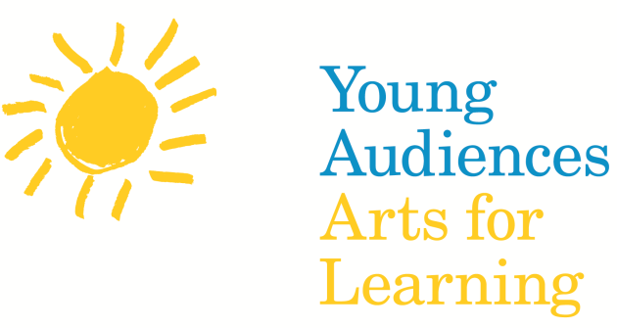

For Immediate Release: Date

Change Headline: Young Audiences Arts for Learning will Host more than 300 Events and Programs across the US in Celebration of National Young Audiences Arts for Learning Week, March 27–April 2, 2016
New York, NY (change city) — Your affiliate name is proud to announce The National Young Audiences Arts for Learning Week (National YA Week). National YA Week will celebrate the many contributions your affiliate name has made to schools in your location/state through its arts in education programs.
ED quote: “National YA Week emphasizes the strength of the National Young Audiences Arts for Learning network and their remarkable collective impact on arts in education” states David A. Dik, YA’s National Executive Director.
The Young Audiences Arts for Learning network will celebrate National YA Week in ## states, working to raise awareness for arts and education initiatives in schools and community venues through public programming, special events, and long-term residencies. It will be observed around the country by ## Young Audiences affiliates in ## states. It is estimated that more than ##### students will be participating in a Young Audiences Arts for Learning program during this week.

Your event info: Highlights include an early education residency performance in New York City; free public presentations of programming in Richmond, Virginia; and a Conference in Connecticut with the theme of creating statewide opportunities with artists with disabilities.
About your affiliate
National Information: For more than 60 years, Young Audiences Arts for Learning (YA) has inspired young people and sought to expand their learning through the arts. Founded in 1952, YA works to support affiliated organizations that are each dedicated to playing a decisive role in young people’s development. Last year, the YA network of 30 affiliates reached 5 million children in over 6,000 schools and community centers with 85,000 performance demonstrations, workshops, and teacher services. This year, Young Audiences of Louisiana opened the very first Young Audiences Charter School, and we continued our work around the network in the media and digital arts through programs like Immersive Game Design in Wichita, Cleveland, and Indiana. These programs teach students to design and produce their own fully-functional digital games and inspire them to harness the power of technology for learning and creating.

The participating Young Audiences affiliates are: TBA

Press Contact: Your contact information
T: 212-860-1563 X108, E: marcus@ya.org
www.youngaudiences.org

